What is sentiments analysis RNN

What is Sentiment Analysis?
sentiment analysis using NLP is a method that identifies the emotional state or sentiment behind a situation, often using NLP to analyze text data. Language serves as a mediator for human communication, and each statement carries a sentiment, which can be positive, negative, or neutral.
Suppose there is a fast-food chain company selling a variety of food items like burgers, pizza, sandwiches, and milkshakes. They have created a website where customers can order food and provide reviews.
For instance,
- User Review 1: “I love this cheese sandwich, it’s so delicious,” is a positive review, indicating customer satisfaction.
- User Review 2: “This chicken burger has a very bad taste,” is negative, highlighting an issue with the burger.
- User Review 3: “I ordered this pizza today,” is neutral, not indicating the customer’s satisfaction.
By analyzing these reviews, the company can conclude that they need to focus on promoting their sandwiches and improving their burger quality to increase overall sales.
Guide to Understand and Implement Natural Language Processing
But, now a problem arises, that there will be hundreds and thousands of user reviews for their products and after a point of time it will become nearly impossible to scan through each user review and come to a conclusion.
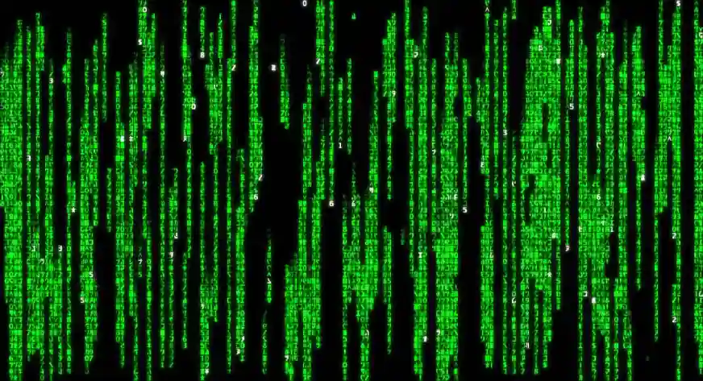
A Sentiment Analysis Model is crucial for identifying patterns in user reviews, as initial customer preferences may lead to a skewed perception of positive feedback. By processing a large corpus of user reviews, the model provides substantial evidence, allowing for more accurate conclusions than assumptions from a small sample of data.
We will explore the workings of a basic Sentiment Analysis model using NLP later in this article. Furthermore, principal sentiments like “positive” and “negative” can be broken down into more nuanced sub-sentiments such as “Happy,” “Love,” “Surprise,” “Sad,” “Fear,” and “Angry,” depending on specific business requirements.
Real-World Example
- Historical Perspective: Initially, social media services like Facebook had only two reactions: “like” or no reaction (dislike).
- Granular Sentiments: Over time, reactions evolved into more granular sentiments such as “like,” “love,” “sad,” and “angry.”
- Enhanced Customer Experience: Companies promoting products on Facebook now receive more specific feedback, improving customer experience.
- Targeted Customer Handling: Granular feedback allows companies to address customers with different sentiments (e.g., “sad” vs. “angry”) more effectively.
- Need for Advanced Sentiment Analysis: Modern business requires more than the bare minimum; targeted strategies based on specific sentiments are essential.
- Challenges of Natural Language: Human communication in natural language is complex and messy, making it challenging for machines to interpret.
- Role of Natural Language Processing (NLP): NLP is needed to help computers understand human language, which includes various styles and sentiments.
- Sentiment Analysis as a Sub-field of NLP: Sentiment Analysis uses machine learning techniques to identify and extract insights from textual data.
Also Read: Sentiment Analysis Using Python
Types of Sentiment Analysis
Sentiment analysis, also known as opinion mining, is a subfield of Natural Language Processing (NLP) that includes deciding and concentrating on the emotional data in an info text. This can be an assessment, an evaluation, or an inclination about a specific point or item. Here are the fundamental sorts of feeling examination:
- Fine-grained Sentiment Analysis: This goes beyond just positive, negative, or neutral. It involves very specific ratings, like a 5-star rating, for example.
- Emotion detection: This aims to detect emotions like happiness, frustration, anger, sadness, etc. The biggest challenge here is being able to accurately identify these emotions in text.
- Aspect-based Sentiment Analysis: This is generally used to understand specific aspects of a certain product or service. For example, in a review like “The battery life of this phone is great, but the screen is not very clear”, the sentiment towards the battery life is positive, but it’s negative towards the screen.
- Multilingual sentiment analysis: This can be particularly challenging because the same word can convey different sentiments in different languages.
- Intent Analysis: This goes a step further to understand the user’s intention behind a certain statement. For example, a statement like “I would need a car” might indicate a purchasing intent.
Sentiment analysis using NLP is a mind boggling task because of the innate vagueness of human language. Mockery, for example, is especially difficult to identify. Subsequently, the precision of opinion investigation generally relies upon the intricacy of the errand and the framework’s capacity to gain from a lot of information.
Also Read: Theory Behind the Basics of NLP
Why Is Sentiment Analysis Important?
NLP for sentiment analysis is important for several reasons:
- Business Intelligence: It helps businesses understand how their customers feel about their products or services. This can guide improvements, address customer concerns, and enhance overall customer satisfaction.
- Market Research: By analyzing public sentiment towards products, services, or brand mentions on social media, companies can gain insights into market trends and competitors.
- Customer Service: Sentiment analysis can help identify negative reviews or feedback in real-time, allowing for quicker responses and problem resolution.
- Product Analytics: It can be used to understand user feedback on various aspects of a product, helping drive product strategy and development.
- Public Relations: Sentiment analysis can help monitor public sentiment towards a company or individual, enabling proactive management of public relations.
- Politics and Public Policy: In politics, sentiment analysis is used to gauge public opinion towards policies or political entities, which can inform strategy and messaging.
Keep in mind, the objective of sentiment analysis using NLP isn’t simply to grasp opinion however to utilize that comprehension to accomplish explicit targets. It’s a useful asset, yet like any device, its worth comes from how it’s utilized.
Sentiment Analysis Challenges
Sentiment analysis, while powerful, comes with its own set of challenges:
- Sarcasm and Irony: These linguistic features can completely reverse the sentiment of a statement. Detecting sarcasm and irony is a complex task even for humans, and it’s even more challenging for AI systems.
- Contextual Understanding: The sentiment of certain words can change based on the context in which they’re used. For example, the word “sick” can have a negative connotation in a health-related context (“I’m feeling sick”) but can be positive in a different context (“That’s a sick beat!”).
- Negations and Double Negatives: Phrases like “not bad” or “not unimpressive” can be difficult to interpret correctly because they require understanding of double negatives and other linguistic nuances.
- Emojis and Slang: Text data, especially from social media, often contains emojis and slang. The sentiment of these can be hard to determine as their meanings can be subjective and vary across different cultures and communities.
- Multilingual Sentiment Analysis: Sentiment analysis becomes significantly more difficult when applied to multiple languages. Direct translation might not carry the same sentiment, and cultural differences can further complicate the analysis.
- Aspect-Based Sentiment Analysis: Determining sentiment towards specific aspects within a text can be challenging. For instance, a restaurant review might have a positive sentiment towards the food, but a negative sentiment towards the service.
These challenges highlight the complexity of human language and communication. Overcoming them requires advanced NLP techniques, deep learning models, and a large amount of diverse and well-labelled training data. Despite these challenges, sentiment analysis continues to be a rapidly evolving field with vast potential.
Applications of Sentiment Analysis
Sentiment Analysis has a wide range of applications across various domains. Here are some key applications:
- Customer Feedback: Businesses use sentiment analysis to process customer feedback and reviews. This helps them understand customer satisfaction and preferences, and make data-driven decisions.
- Social Media Monitoring: Brands monitor social media platforms to understand public sentiment about their products or services. This can help in reputation management and in identifying potential crises before they escalate.
- Market Research: Sentiment analysis can be used to understand public opinion about a product or a political event. This can provide valuable insights for market research.
- Product Analytics: Companies use sentiment analysis to gather insights from product reviews. This can guide product enhancements and innovations.
- Healthcare: In healthcare, sentiment analysis can be used to understand patient experiences and feedback about treatments, doctors, or hospitals.
- Finance: In the financial sector, sentiment analysis is used to gauge market sentiment. Traders and investors use this information to make informed decisions.
- Politics: In politics, NLP for sentiment analysis is used to understand public opinion about certain policies or politicians. This can guide political campaigns and strategies.
- Human Resources: HR departments use sentiment analysis using NLP to understand employee feedback and improve workplace culture.
Remember, these are just a few examples. The potential applications of sentiment analysis are vast and continue to grow with advancements in AI and machine learning technologies.

Integer encoding:
First we will form our vocab. Our vocab will contain unique words from the dataset. Each of the unique words will be assigned a number.
So lets say that for a sentence hi there , hiis assigned as 1 and thereis assigned as 2. So this sentence in the vector form will be like this : [1,2]
Now, it may happen that another sentence may be of different length than this. So to deal with this we will do padding
So we will add 0 before or after the end of the sentence
CODE:
import numpy as np
docs = ['go india',
'india india',
'hip hip hurray',
'jeetega bhai jeetega india jeetega',
'bharat mata ki jai',
'kohli kohli',
'sachin sachin',
'dhoni dhoni',
'modi ji ki jai',
'inquilab zindabad']
'''
Tokenizer removes stop words, converts all words to lower case letters, removes special symbols etc
oov_token stands for out of vocabulary which means lets say at the time of prediction
there is a word which is not there in the vocabulary, it will replace that word w
with the word given in the oov_token
'''
from keras.preprocessing.text import Tokenizer
tokenizer = Tokenizer(oov_token='<nothing>')
tokenizer.fit_on_texts(docs) # will convert words to integers
tokenizer.fit_on_texts(docs)
'''
{'<nothing>': 1,
'india': 2,
'jeetega': 3,
'hip': 4,
'ki': 5,
'jai': 6,
'kohli': 7,
'sachin': 8,
'dhoni': 9,
'go': 10,
'hurray': 11,
'bhai': 12,
'bharat': 13,
'mata': 14,
'modi': 15,
'ji': 16,
'inquilab': 17,
'zindabad': 18}
'''
tokenizer.word_counts
'''
OrderedDict([('go', 1),
('india', 4),
('hip', 2),
('hurray', 1),
('jeetega', 3),
('bhai', 1),
('bharat', 1),
('mata', 1),
('ki', 2),
('jai', 2),
('kohli', 2),
('sachin', 2),
('dhoni', 2),
('modi', 1),
('ji', 1),
('inquilab', 1),
('zindabad', 1)])
'''
tokenizer.document_count # gives us the total number of sentences
sequences = tokenizer.texts_to_sequences(docs)
sequences
'''
[[10, 2],
[2, 2],
[4, 4, 11],
[3, 12, 3, 2, 3],
[13, 14, 5, 6],
[7, 7],
[8, 8],
[9, 9],
[15, 16, 5, 6],
[17, 18]]
'''
from keras.utils import pad_sequences
sequences = pad_sequences(sequences,padding='post')
# post means adding padding after the end of the sentence
# pre means adding padding before the starting of the sentence
sequences
'''
array([[10, 2, 0, 0, 0],
[ 2, 2, 0, 0, 0],
[ 4, 4, 11, 0, 0],
[ 3, 12, 3, 2, 3],
[13, 14, 5, 6, 0],
[ 7, 7, 0, 0, 0],
[ 8, 8, 0, 0, 0],
[ 9, 9, 0, 0, 0],
[15, 16, 5, 6, 0],
[17, 18, 0, 0, 0]], dtype=int32)
'''
from keras.datasets import imdb
from keras import Sequential
from keras.layers import Dense,SimpleRNN,Embedding,Flatten
(X_train,y_train),(X_test,y_test) = imdb.load_data()
X_train[0] # we will not be able to see sentences in textual format, directly it will be visible in numbers
len(X_train[2]) # length of the 2nd sentence in X_train, i.e no of words in the 2nd sentence
X_train = pad_sequences(X_train,padding='post',maxlen=50)
X_test = pad_sequences(X_test,padding='post',maxlen=50)
'''
Doing padding and taking only first 50 words from each sentence for X_train and X_test
'''
X_train[0]
model = Sequential()
model.add(SimpleRNN(32,input_shape=(50,1),return_sequences=False))
model.add(Dense(1,activation='sigmoid'))
model.summary()
# Here 32 means the number of nodes in the hidden layer
# 50, 1 -> 50 means timestamps and 1 is the input feature
# Here at t=1 element 1 will enter RNN, at t = 2 element 2 will enter RNN and so on
# here if return_sequences is true we will see the output everytime a word is sent to the RNN
# since it is set to false it will directly give us the final output
Press enter or click to view image in full size
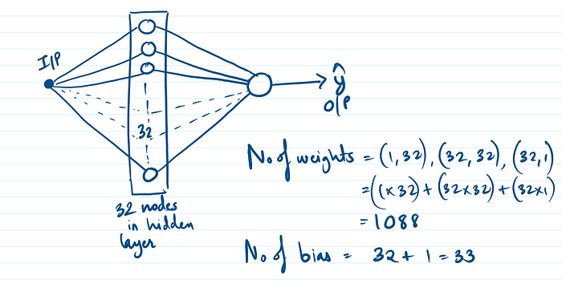
Our RNN architecture looks like this
model.compile(loss='binary_crossentropy',optimizer='adam',metrics=['accuracy'])
model.fit(X_train,y_train,epochs=5,validation_data=(X_test,y_test))
Embeddings
In NLP, word embedding is a term used for representation of words used for text analysis, typically in the form of a real valued vector that encodes the meaning of the word such that the words that are closer in the vector space are expected to be similar in meaning
The vector when we use embedding is dense which means it has non zero values in it. So when we used one hot encoding it was a sparse technique where a lot of values were zero
Word embeddings are able to capture the semantic meaning which means it is able to understand in which context it is being used
Example : word2vec, glove are word embedding techniques
In keras, we have embedding layer. At the start of our RNN we can put an embedding layer which automatically will create the dense representation of all our words and then will send this dense representation to the RNN
We have to make sure that whatever data we are putting in the embedded layer, it should be integer encoded, rest everything embedding layer handles automatically
model = Sequential()
model.add(Embedding(17,2,5)
model.add(SimpleRNN(32,return_sequences = False))
model.add(Dense(1, activation = 'sigmoid'))
model.summary()
'''
17 -> length of the vocabulary meaning number of unique words in the vocabulary
2 -> dimension of the dense vector you want to make, here it means that we want
to represent each word with 2 numbers. It is a hyperparameter and we can change it to our will
5 -> max size of the input sentence
32 -> number of nodes in the hidden layer
'''
Press enter or click to view image in full size
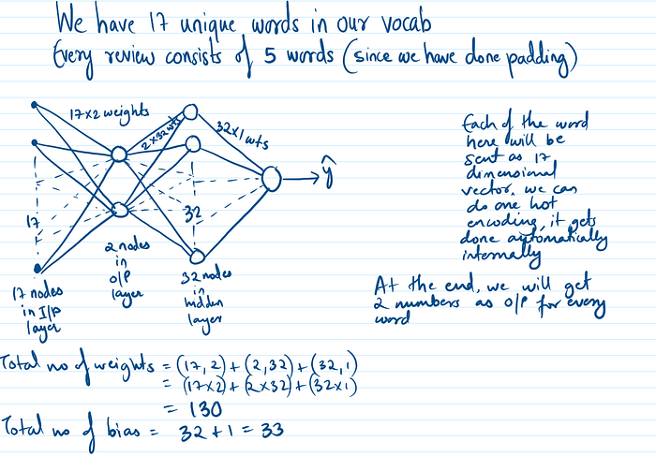
How our RNN will look like when we use embeddings
model.compile('adam', 'accuracy')
pred = model.predcit(sequences)
print(pred)

Rnn Architecture

Embedding

Word Embeddings

Vector Embeddings

Deep Learning

